<http://letsmakerobots.com/content/fundamentals-gps-guided-vehicle>

<http://www.instructables.com/id/Make-A-Simple-Bidepal-Humanoid-Robot/>

# Simon's Omnidirectional 4-wheeled Robot (modified Robodyssey Mouse)

<http://www.thingiverse.com/thing:267422>

BOB

<http://www.thingiverse.com/thing:43708>

Robot BOB

<http://www.thingiverse.com/thing:371158>

Plobot

<http://www.thingiverse.com/thing:730180>

Fred a BOB Robot

<http://www.thingiverse.com/thing:594761>

# RAPIRO - The Humanoid Robot for your Raspberry Pi

<http://www.thingiverse.com/thing:309466>

# SEHS Servo Bot

<http://www.thingiverse.com/thing:543267>

# MegaPed Servo I Brace

<http://www.thingiverse.com/thing:20054>

Bug Bot

<http://www.thingiverse.com/thing:663056>

Sumobot Chassis

<http://www.thingiverse.com/thing:1292>

Sumobot Chassis v2

<http://www.thingiverse.com/thing:1548>

Printable Sumo Bot Jr Kit

<http://www.thingiverse.com/thing:357369>

# ArduSkyBot v1.0, an open source educational printbot

<http://www.thingiverse.com/thing:26818>

# ArduSkyBot v2.0

<http://www.thingiverse.com/thing:28540>

# RPMBot

<http://www.thingiverse.com/thing:23753>

# Delta Robot v1 with three arms

<http://www.thingiverse.com/thing:44235>

# MiniSkybot Robot Chassis

<http://www.thingiverse.com/thing:4954/#files>

# Squirrel Chasing Robot

<http://www.thingiverse.com/thing:372541>

# Caterpillator v1.1

<http://www.thingiverse.com/thing:8559>

# Howme the robot

<http://www.thingiverse.com/thing:9106>

# TOM Tri-Track dual servo robot tank chassis

<http://www.thingiverse.com/thing:19170>

# ArduBot - 3D Printed Arduino robot

<http://www.thingiverse.com/thing:603907>

# Delta Robot v1 with four arms

<http://www.thingiverse.com/thing:46970>

# C-Spot Robot

<http://www.thingiverse.com/thing:38073>

# B-BOT: The Cheap Helper Robot for people in need

<http://www.thingiverse.com/thing:68762>

# Mobile Robot, With Printable Gearbox

<http://www.thingiverse.com/thing:4282>

# Light Seeking Robot

<http://www.thingiverse.com/thing:41184>

# Delta Robot - Yazzo PolyBot Derivative

<http://www.thingiverse.com/thing:7554>

# Printable Rescue Robot for Minery

<http://www.thingiverse.com/thing:31929>

# Eric's Sainsmart 4WD Arduino Robot Code

<http://www.thingiverse.com/thing:183896>

# MiniSkybot Robot V1.0

<http://www.thingiverse.com/thing:7989>

# Robotic arm with 6 DOF

<http://www.thingiverse.com/thing:30163>

# Apogee - Raspberry Pi Robot

<http://www.thingiverse.com/thing:648394>

# 9G Octopod

<http://www.thingiverse.com/thing:449397>

# Hexapod-IS

<http://www.thingiverse.com/thing:309755>

# Tripods are coming ...

<http://www.thingiverse.com/thing:61949>

# Rubber legs for more grip!

<http://www.thingiverse.com/thing:53120>

# Mini Quadruped - optimized for 9G servos

<http://www.thingiverse.com/thing:38159>

# Skybot based printable robot with two ultrasonic sensors

<http://www.thingiverse.com/thing:524211>

# OpenSource RobotArm

<http://www.thingiverse.com/thing:175831>

Felix v2

<http://burningservos.com/>

<https://github.com/Traverso/JSFelix/tree/master/Hardware/CAD>

<http://letsmakerobots.com/robot/project/felix-v2>

Another Robot Arm - Perfect for Arduino Beginners

<http://lifehacker.com/build-a-kickass-robot-arm-the-perfect-arduino-project-1700643747>

DIY Robot Solder by Brain Dorey

<http://briandorey.com/category/Soldering-Robot-Project.aspx>

Android Controlled Arduino Bluetooth Panzer

<http://www.instructables.com/id/Android-Controlled-Arduino-Bluetooth-Panzer/?ALLSTEPS>

Soft Robots: Make an Artificial muscle arm and gripper

<http://www.instructables.com/id/Soft-Robots-Make-An-Artificial-Muscle-Arm-And-Gri/?&sort=ACTIVE&limit=40#DISCUSS>

<http://makerflux.com/soft-robots-make-an-artificial-muscle-arm-and-gripper/?utm_content=buffereda10&utm_medium=social&utm_source=plus.google.com&utm_campaign=buffer>

Spider Rover:

This 3D printed creature can be simply clicked together with one and the same printed lock washer type.

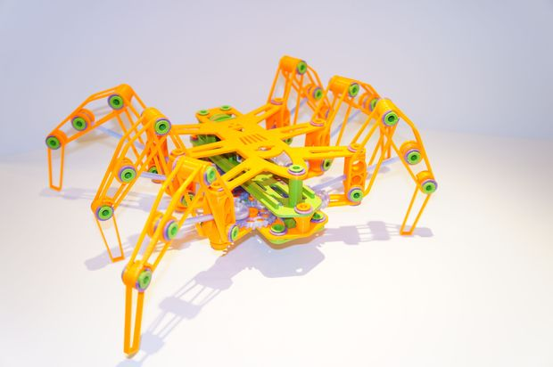

<http://www.instructables.com/id/3D-Printed-creature/>

Talking Arduino-Powered Robot Head:

<http://www.instructables.com/id/Build-an-Arduino-powered-talking-robot-head/>

Pablo

<https://hackaday.io/project/1533-pablo>

Robofish:

<http://www.open-electronics.org/robofish-create-your-robot-fish-with-arduino/>

Arduino Nano based Microbot

<http://www.instructables.com/id/Arduino-Nano-based-Microbot/>

MultiTasking Robot with Devastator Platform

<http://www.dfrobot.com/index.php?route=DFblog/blog&id=353&utm_medium=email&utm_campaign=Thirty+Five+Days+of+Crowdfunding+Awesomeness!&utm_source=YMLP&utm_term=image+384>

How to Make a Bionic Beetle Robot

<http://www.dfrobot.com/index.php?route=DFblog/blog&id=361&utm_medium=email&utm_campaign=Thirty+Five+Days+of+Crowdfunding+Awesomeness!&utm_source=YMLP&utm_term=image+384>

SUMOBOT JR

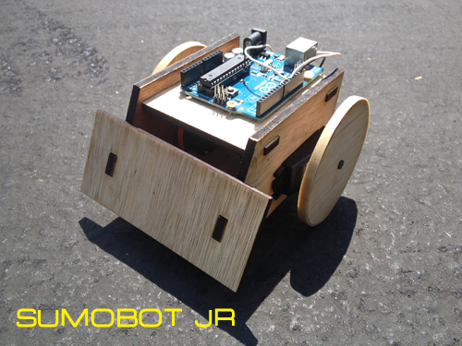

<https://github.com/makenai/sumobot-jr>

<http://inspiredtoeducate.net/inspiredtoeducate/sumobot-jr-fun-open-source-robot-kit-using-arduino-and-javascript/?utm_content=buffer9571d&utm_medium=social&utm_source=plus.google.com&utm_campaign=buffer>

NOT A ROBOT PERSAY, IT’s SumoBot Code for the Arduino

<https://github.com/NorthernStars/sumoino>

Society of Robots Omni-Wheel Drive information:

<http://www.societyofrobots.com/robot_omni_wheel.shtml>

How to Waterproof a servo

<http://www.societyofrobots.com/actuators_waterproof_servo.shtml>

Taurus 2 Robot - an omni drive robot using servos and standard wheels.

<http://www.societyofrobots.com/robot_taurus2.shtml>